**CS590 Big Data Analysis**

**Lab2**

* **Implementing an application showing following activities:**

-Gyroscope

-Time

-GPS (latitude and longitude)

-Acceleration

* When we run android application following output will be appear.

Devices used (galaxy nexus7 and sensor device)

User DDMS perspective-> logcat ->info (navigate to see the output)

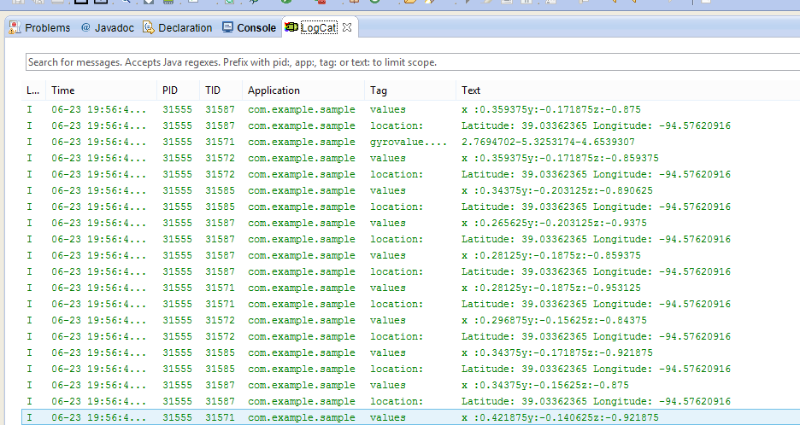

* After execution ,under astrofile manager a file will be generated named “sensor.txt” where all actives above listed will be shown.
* **Now executing Hbase client application and inserting generated txt file into Hbase**

-Following output will be produced after inserting “sensort.txt”

Operation performed using above application: a) createtable b)inserttable c)reterive table c) fetiching all rows d) deleting table e) fetching all table values.

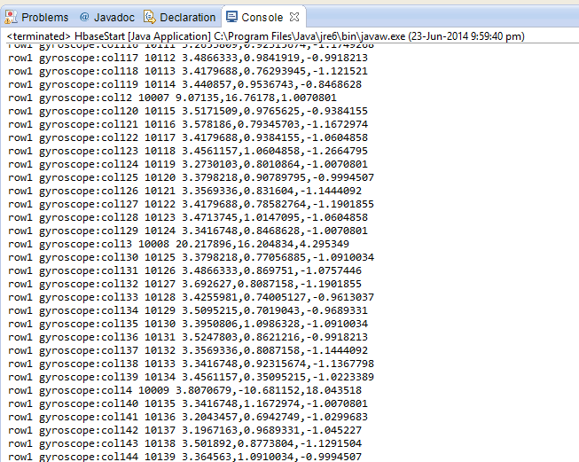

**Displaying gyroscope**

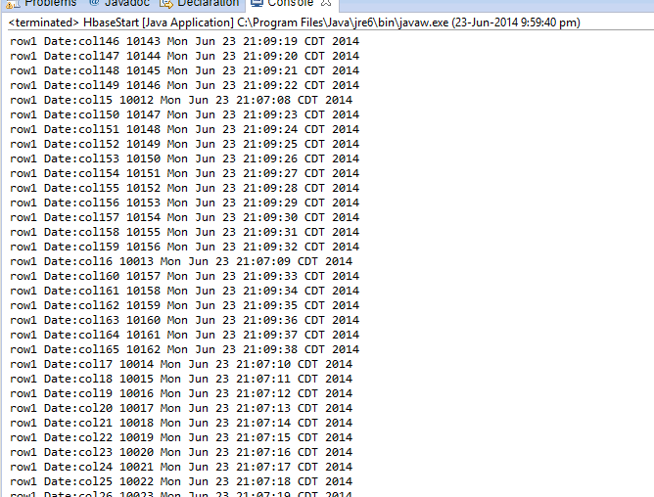

**Displaying date parameters**

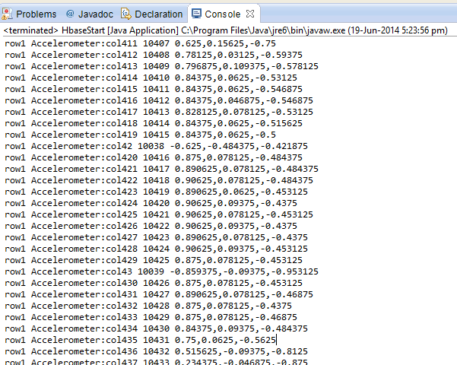

**Displaying accelerometer**

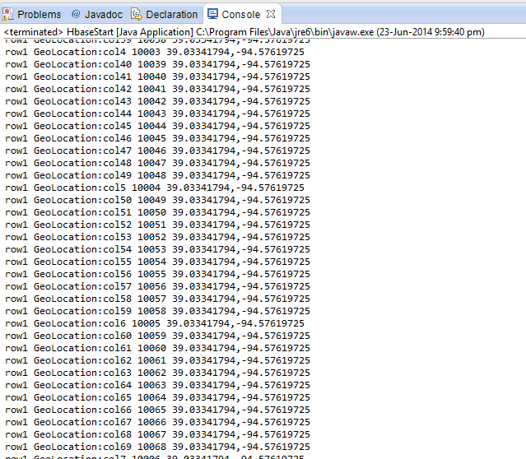

**Displaying Geolocation**